PROJECT NAME

## A PROJECT REPORT

submitted by

**YOUR NAME**

**REG NO**

## to

The APJ Abdul Kalam Technological University

in partial fulfillment of the requirements for the award of the Degree of

Master of Computer Applications

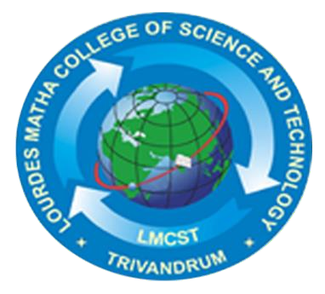

# Department of Computer Applications

## LOURDES MATHA COLLEGE OF SCIENCE AND TECHNOLOGY KUTTICHAL, THIRUVANANTHAPURAM

JULY 2021